The Technologies that we used.

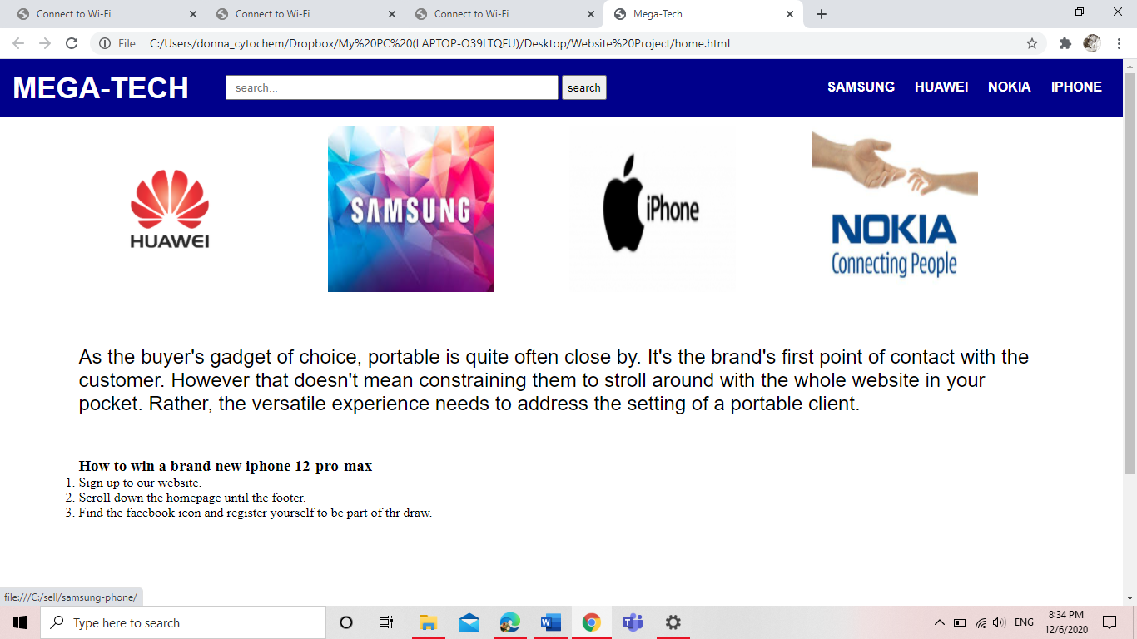

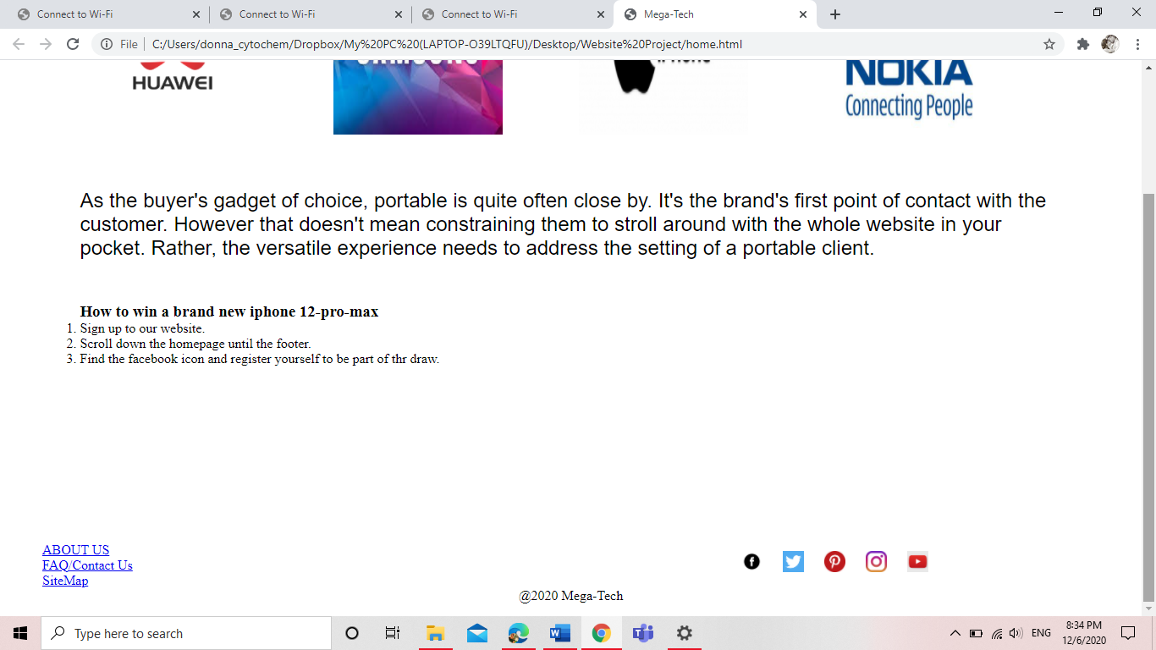

We used Html to create the element of the website and CSS to style them.

We used the input search type to create the search bar.

We used div tags to section the page and img tag to insert graphics in the page to align them in one row we had to use the CSS float property.

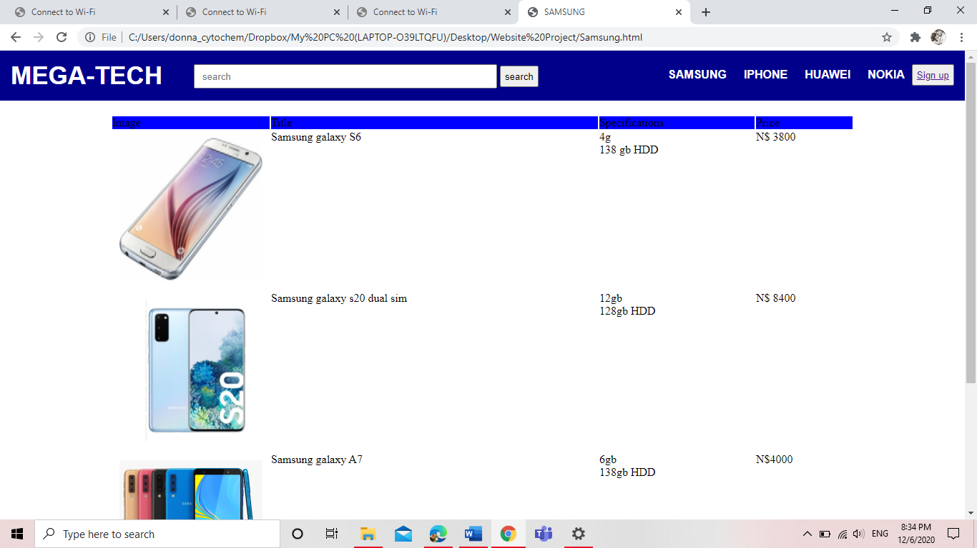

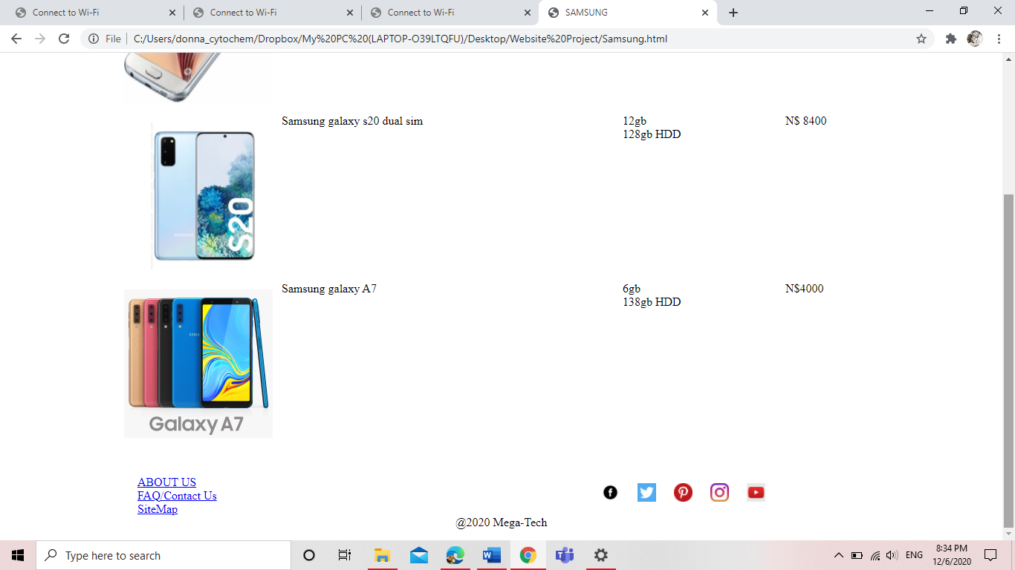

We used the table tag to organise the different types of phones and under the specifications columns we used an unordered list to list out the specifications.

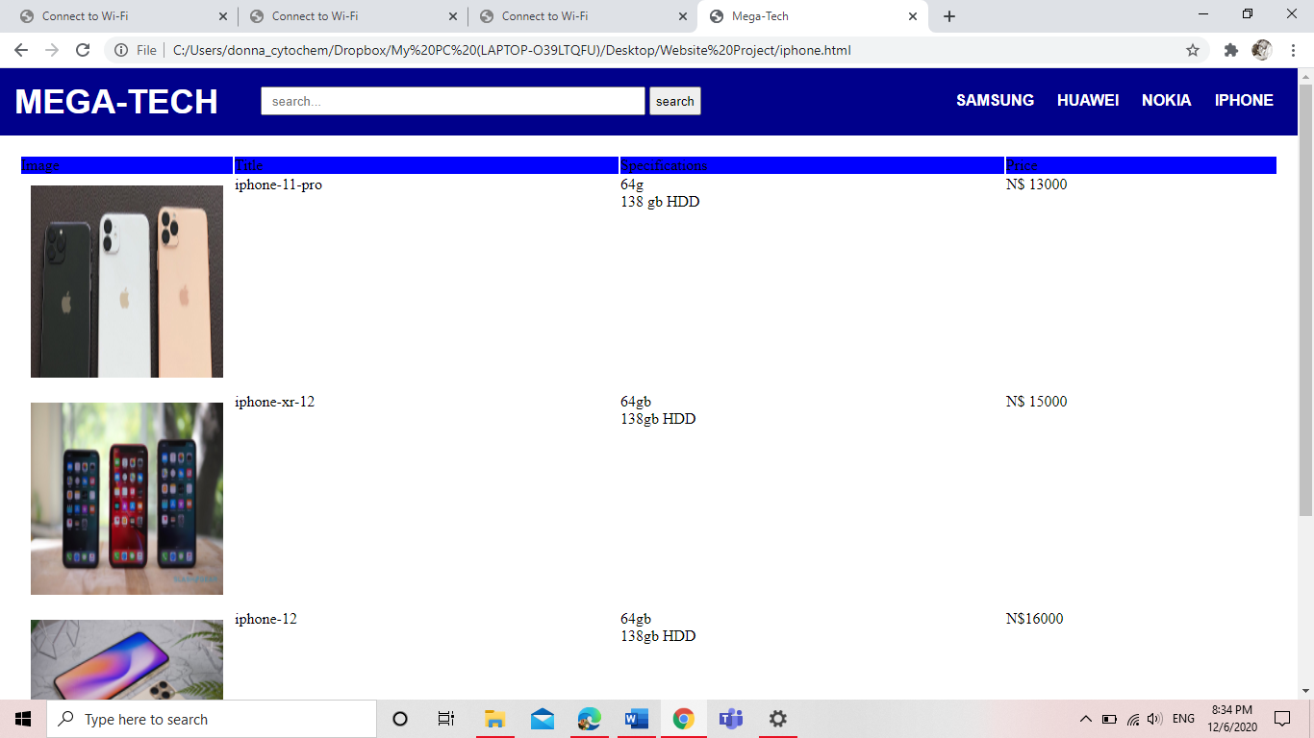

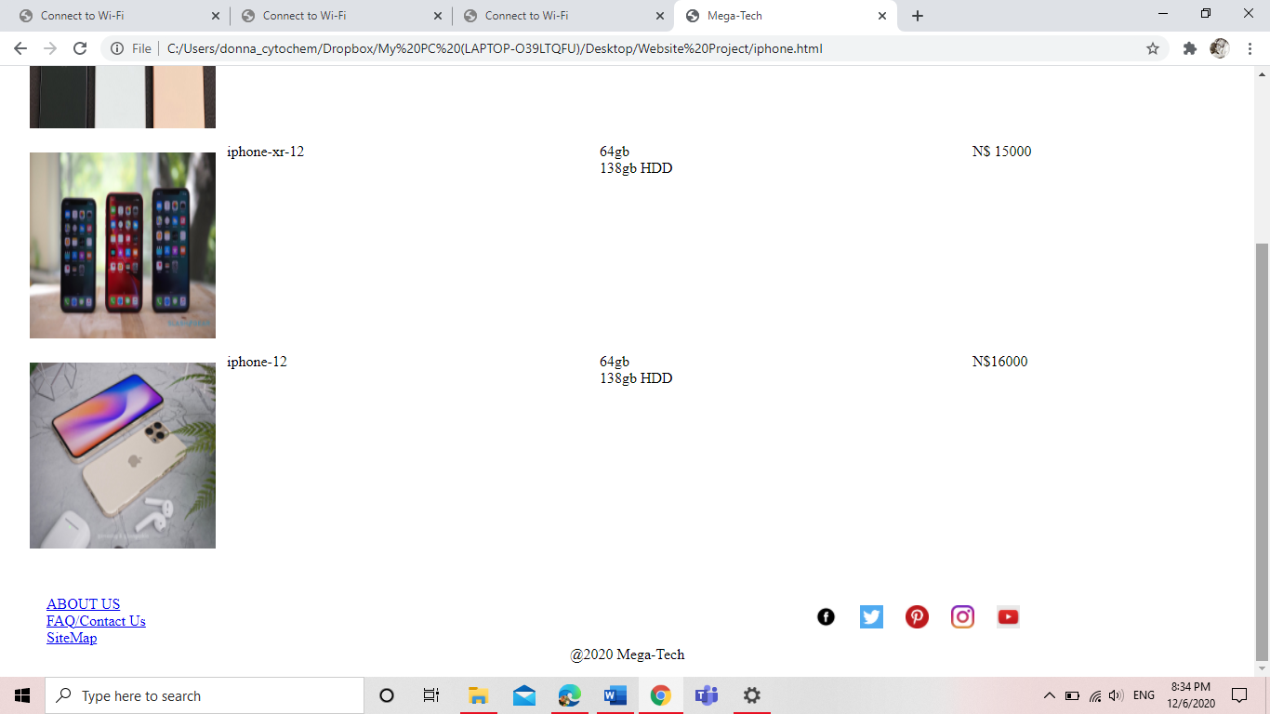

For the footer we used another list to organise the different ways people can reach out to us.

We added links to our social media platforms (a tag).

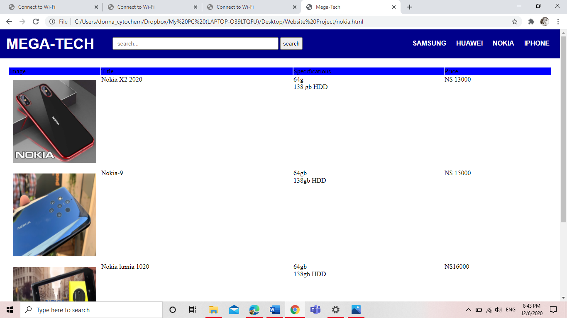

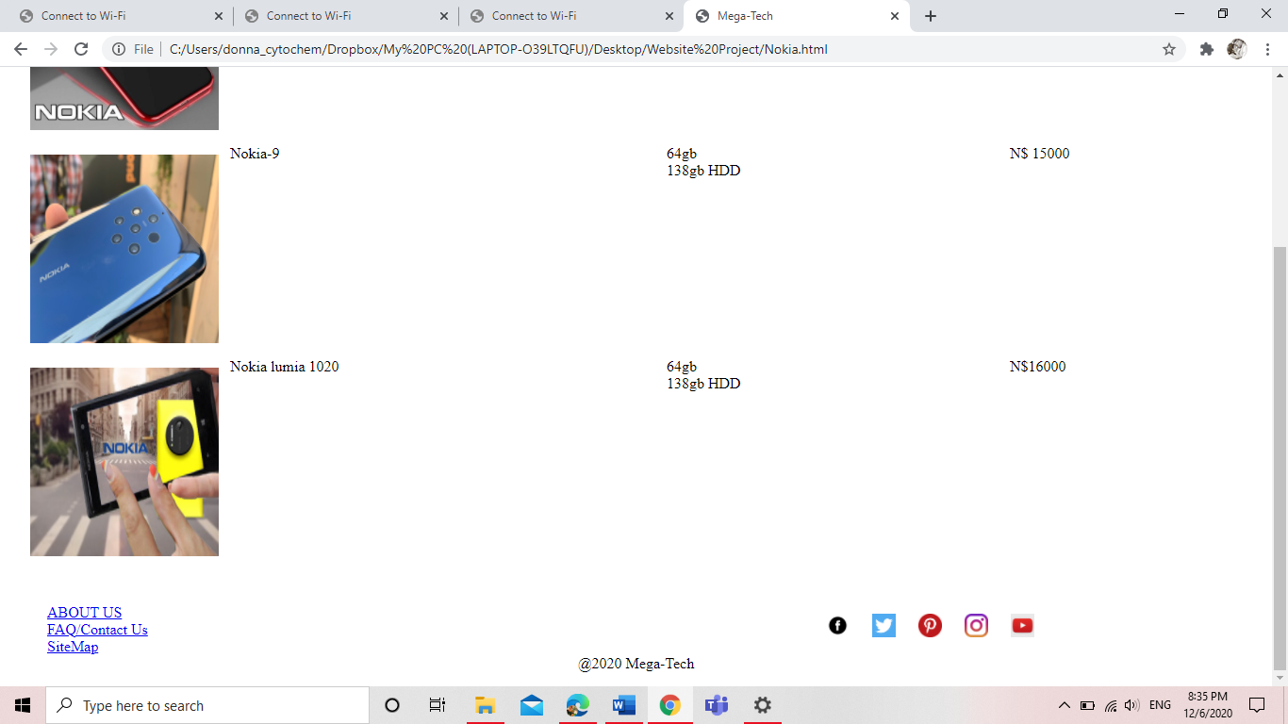

To align them horizontally we had to use a float property because divs are block elements.

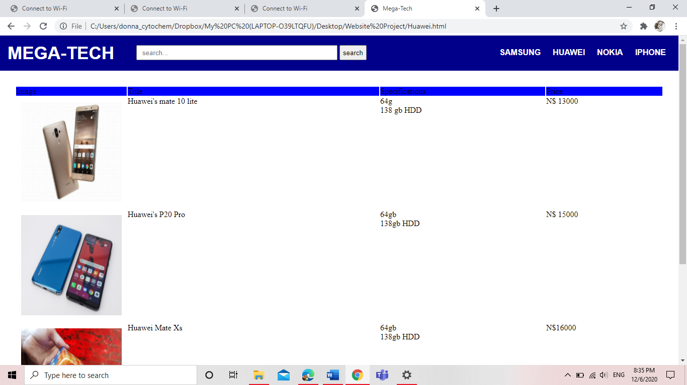

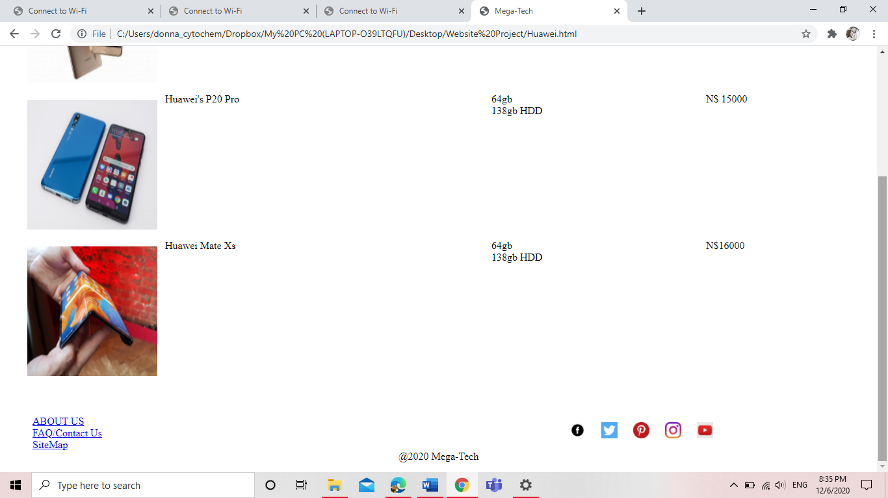

We used a CSS styling to get a white and blue background color.

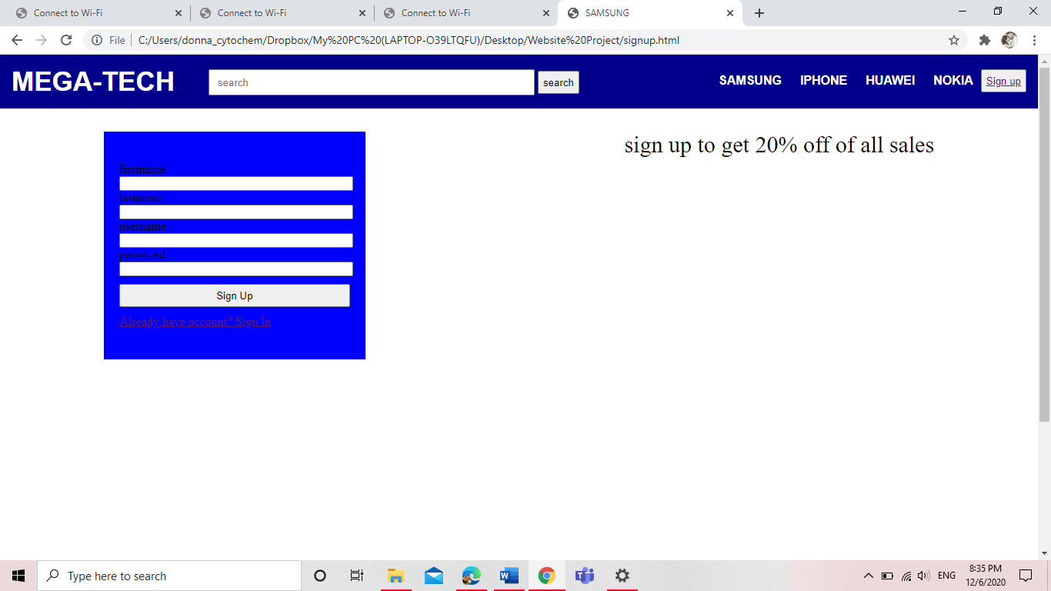

For the sign up and sign in functionality we had to use the html form element.

The first name, last name and username are text type.

The password is a password input type, whilst the sign in button is a submit type.

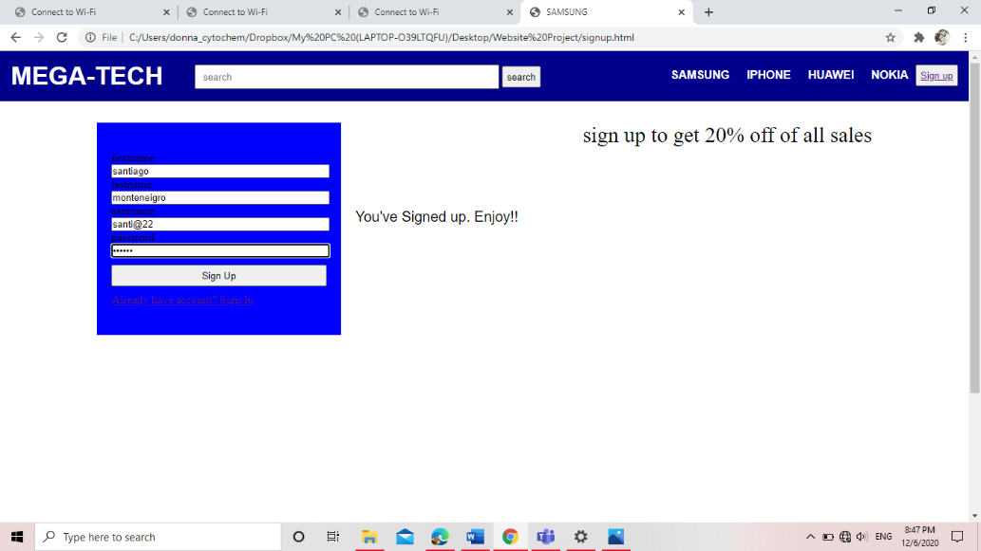

There is a JavaScript event listener to display to the user that they have signed up after they click the sign up button.